Chapter 8, Problem 38.

Refer to the circuit in Fig. 8.86. Calculate i(t) for t > 0.
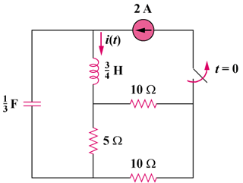

2[1 – u(t)] A


Figure 8.86
For Prob. 8.38.

